**Protein-macromolecule interactions heat dependence and machine learning**

251024 group discussion M1 Shunya Sudo

**Research Objectives**

　Our objective is to engineer composition-optimized random copolymers that form a compliant, chaperone-like shell around enzymes—primarily glucose oxidase (GOx) and, additionally, lipase (Lip)—to maximize thermal resistance without sacrificing native activity1. To form such a shell, protein–polymer interactions should be “strong enough to favor adsorption yet soft enough not to outcompete the forces governing protein folding.” 1 Because protein surfaces present chemical patches with characteristic length scales of ~1–2 nm, we prioritize controlling the statistical monomer distribution rather than the specific sequence in our polymer design1.

Operationally, we explore a ternary MPC/MTAC/BMA space tailored to GOx and use active ML: “five iterations of a Learn–Design–Build–Test cycle” with an enzyme-specific GPR surrogate and Bayesian optimization of copolymers to propose high-performing candidates that “preserve, or even enhance, the activity” after heating2.

We then generalize by substituting the hydrophobic unit (EHMA, LMA, MPTSSi) and leveraging Bayesian optimization as a proven alternative to high-throughput screening in polymer composition problems3.

黒い背景と白い文字の絵

AI 生成コンテンツは誤りを含む可能性があります。

|  |  |  |  |  |  |  |  |  |
| --- | --- | --- | --- | --- | --- | --- | --- | --- |
|  |  |  | **Feed Ratio (mol %)** | | | **Composition Ratio (mol %)** | | |
|  | $$\frac{\left[BMA\right]}{\left[BMA\right]+ \left[MTAC\right]}$$ | $$\frac{\left[BMA\right]+ \left[MTAC\right]}{\left[MPC\right]+ \left[BMA\right]+ \left[MTAC\right]}$$ | **MPC** | **BMA** | **MTAC** | **MPC** | **BMA** | **MTAC** |
| PMBTA-1 | 0.2 | 0.2 | 80 | 4 | 16 | 84.4 | 2.5 | 13.1 |
| PMBTA-2 | 0.8 | 0.2 | 80 | 16 | 4 | 78.6 | 15.9 | 5.5 |
| PMBTA-3 | 0.2 | 0.7 | 30 | 14 | 56 | 30.4 | 14.2 | 55.4 |
| PMBTA-4 | 0.8 | 0.7 | 30 | 56 | 14 | 32.7 | 33.2 | 34.1 |
| PMBTA-5 | 0.5 | 0.45 | 55 | 22.5 | 22.5 | 50.3 | 22.4 | 22.4 |
| PMPC | - (0.5) | 0 | 100 | 0 | 0 | 100 | 0 | 0 |
| PMTAC | 0 | 1 | 0 | 0 | 100 | 0 | 0 | 100 |

**Summary of this report**

・resynthesis PMBTA and synthesis PMPC, PMTAC

・Aggregation state and zeta potential of the copolymer(s)  
・Aggregation state and zeta potential of lipase and GOx in an aqueous medium containing 1 vol% EtOH  
・Thermostability enhancement of lipase by the PMBTA copolymer  
・Thermostability enhancement of GOx by the PMBTA copolymer

1. **Resynthesis PMBTA and synthesis PMPC, PMTAC**

PMBTA was resynthesized. To verify that the ternary copolymer architecture contributes to thermal stability, the corresponding homopolymers were additionally synthesized.

* 1. **Experimental Methods**

1. 2-Methacryloyloxyethyl phosphorylcholine (MPC) (426 mg, 126 mol), [2-(methacryloyloxy)ethyl]trimethyl- ammonium chloride (MTAC) (60mg, 12mol), Butyl Methacrylate (BMA) (10mg, 1.5mol) were weighed and added to the test tube. The molar ratio was 8: 0.4: 1.6.
2. Solvent (CHCl3/EtOH 6:4 mol) was added to 4ml test tube.
3. The test tube was stirred at 59°C to dissolve the ligand.
4. (4) 2-Cyanopropan benzodithioate-2-yl (CPB) (5mg, 0.0225mmol) and AIBN (α,α'-azobisisobutyronitrile) (2.5mg, 0.0152mmol) were weighed into a vial bottle. (2.5 mg, 0.0152 mmol) were weighed into a vial and dissolved in 500 μL of solvent, respectively.
5. The warmed test tubes were removed and nitrogen bubbling was performed for 10 minutes.
6. After 8minutes of nitrogen bubbling, 500 μL of the solution of (4) was added.
7. (6) After 7minutes of nitrogen bubbling, the tubes were sealed with Parafilm and grease and allowed to react at 59°C for 24 hours in a constant-temperature water bath.
8. The reaction proceeded and the solution coagulated to a jelly-like state.
9. 3mL of solvent was added and dissolved by ultrasound and spatchera.
10. The solution was re-precipitated by adding to chloroform and collected on filter paper.
11. The polymer was collected by drying under reduced pressure for 24 hours.
12. **Measurement of particle size distribution**
    1. **Experimental Methods**
13. The polymer was dissolved in water containing 1 vol% EtOH to prepare 3 mg/mL polymer solutions.
14. 780 μL of (1) was used for measurement.

**2.2 Particle size distribution (PMBTA)**

　Particle size distribution was measured for each of PMBTA-1-5.

グラフ, ヒストグラム

AI 生成コンテンツは誤りを含む可能性があります。

**Figure 1**. Particle size distribution of PMBTA with 1% EtOH (2025/10).

* For PMBTA, the particle size (hydrodynamic diameter) was smaller than that of PMPC and PMTAC.
  + The incorporation of BMA may suppress polymer swelling via hydrophobic interactions intrinsic to the polymer.
  + Introducing hydrophobic units can promote a single-chain “folded” (intrachain collapse) conformation.

Nagao*, ACS Macro Lett.* **2025**, 14, 7, 989–995

**2.3** **Particle size distribution (Lip and GOx)**

Particle size distribution of lipase and GOx under 1 vol% EtOH was measured.

Solvent: water, Concentration: 3 mg/mL

グラフ, 折れ線グラフ, ヒストグラム

AI 生成コンテンツは誤りを含む可能性があります。

**Figure 2**. Particle size distribution of Lipase with 1% EtOH (2025/10).

* For lipase, the particle size distribution was essentially unchanged in 1 vol% EtOH.

グラフ, ヒストグラム

AI 生成コンテンツは誤りを含む可能性があります。

**Figure 3**. Particle size distribution of GOx with 1% EtOH (2025/10).

* For GOx, the particle size distribution was likewise essentially unchanged in 1 vol% EtOH.

**2.4** **Particle size distribution (Lip and GOx + Polymer)**

Lipase (3 mg mL⁻¹) and PMBTA (3 mg mL⁻¹) were each added at 0.5 mL, and the particle size distribution was measured.

グラフ, ヒストグラム

AI 生成コンテンツは誤りを含む可能性があります。

**Figure 4**. Particle size distribution of Lip + PMBTA with 1% EtOH (2025/10).

* Upon polymer addition, lipase showed virtually no change in particle size distribution.

GOx (3 mg mL⁻¹) and PMBTA (3 mg mL⁻¹) were each added at 0.5 mL, and the particle size distribution was measured.

グラフ, ヒストグラム

AI 生成コンテンツは誤りを含む可能性があります。

**Figure 5**. Particle size distribution of GOx + PMBTA with 1% EtOH (2025/10).

* Upon polymer addition to GOx, the particle size shifted to larger values.
* This observation suggests aggregation of the polymer around GOx.

1. **Measurement of zeta potential**

Zeta potential was measured using a PMBTA solution (3 mg mL⁻¹).

**3.1** **Zeta potential (Polymer)**

**グラフ

AI 生成コンテンツは誤りを含む可能性があります。**

**Figure 6**. Zeta potential of PMBTA with 1% EtOH (2025/10).

* Except for PMBTA-5, the zeta potential increased with increasing MTAC feed ratio.

**3.2** **Zeta potential (Lip and GOx)**

Zeta potential of lipase and GOx (3 mg mL⁻¹) was measured under 1 vol% EtOH.

グラフ

AI 生成コンテンツは誤りを含む可能性があります。

**Figure 7**. Zeta potential of Lip (2025/10)

* It was confirmed that 1 vol% EtOH had no appreciable effect on the zeta potential of lipase.

グラフ

AI 生成コンテンツは誤りを含む可能性があります。

**Figure 8**. Zeta potential of GOx (2025/10)

* It was confirmed that 1 vol% EtOH had no appreciable effect on the zeta potential of GOx.

**3.3** **Zeta potential (Lip and GOx +Polymer)**

グラフ

AI 生成コンテンツは誤りを含む可能性があります。

**Figure 9**. Zeta potential of Lip + Polymer (2025/10)

* Polymers with higher MTAC content shifted the net charge of neat lipase toward more positive values.

グラフ

AI 生成コンテンツは誤りを含む可能性があります。

**Figure 10**. Zeta potential of GOx (2025/10)

* Except for pure PMTAC, the zeta potential increased in proportion to the MTAC content.
  + When the net positive charge becomes too large, cationic patches may be buried in the interior rather than exposed at the surface.

1. **Enjzyme Assay (Lip)**

I investigated how a 1 vol% EtOH environment affects the thermal stability of lipase.

Concentration Lip: 0.025 mg/mL

グラフ, 折れ線グラフ

AI 生成コンテンツは誤りを含む可能性があります。

**Figure 11**. Lip assay with or without EtOH (left: Absolute activity, right: Retain Enzyme Activity)

* Lipase showed no appreciable change in thermal stability under 1 vol% EtOH.
* Under the present conditions (Concentration: 0.025 mg mL⁻¹, Temperature: 60 °C), after 40 min of heating the REA of neat lipase decreases to ~20%.

Investigation of lipase thermostability upon heating in the presence of PMBTA

Concentration Lip: 0.025 mg/mL, Polymer: 0.025 mg/mL,　EtOH 1%

グラフィカル ユーザー インターフェイス, グラフ

AI 生成コンテンツは誤りを含む可能性があります。

**Figure 12**. Lip assay with PMBTA (left: Absolute activity, right: Retain Enzyme Activity)

* Thermostability improved upon addition of PMBTA-3, PMTAC, and PMBTA-1.
* Because the homopolymer PMTAC enhances thermostability, positive charge is implicated in lipase stabilization.

1. **Enjzyme Assay (GOx)**

Investigation of how 1 vol% EtOH affects the thermostability of GOx

Concentration GOx: 0.0016 mg/mL

グラフ, 折れ線グラフ

AI 生成コンテンツは誤りを含む可能性があります。

**Figure 13**. GOx assay with or without EtOH (left: Absolute activity, right: Retain Enzyme Activity)

* Lipase showed no change in thermostability under 1 vol% EtOH.
* Under the present conditions (Concentration: 0.0016 mg mL⁻¹, Temperature: 60 °C), after 40 min of heating the REA of neat GOx decreases to 0%.

Investigation of GOx thermostability upon heating in the presence of PMBTA

Concentration GOx: 0.0016 mg/mL, Polymer: 0.025 mg/mL

グラフィカル ユーザー インターフェイス, グラフ, ダイアグラム, ヒストグラム

AI 生成コンテンツは誤りを含む可能性があります。

**Figure 14**. GOx assay with PMBTA (left: Absolute activity, right: Retain Enzyme Activity)

* All polymers except PMPC improved thermostability.
* For the homopolymers PMPC and PMTAC, the improvement in thermostability was absent or minimal.
* Rather than “more MTAC is better,” the response is non-monotonic, exhibiting a composition-dependent optimum.
  + PMBTA-4 and 5, which contain a well-balanced mix of hydrophilic, hydrophobic, and cationic properties, rank highly.
  + The GOx surface presents a chemically heterogeneous mosaic with characteristic patch diameters and inter-patch distances on the order of 1–2 nm; thus a chaperone-like polymeric shell that adsorbs via multiple weak, noncovalent interactions is required. Interactions should be strong enough to favor adsorption yet soft enough not to disrupt folding; by contrast, single-mode binding by homopolymers can perturb protein structure (e.g., PMPC- or PMTAC-like extremes in our system).
  + Because protein surfaces are chemically heterogeneous (hydrophobic, neutral hydrophilic, positively and negatively charged patches), heteropolymers designed to match the surface pattern and optimized in their statistical monomer distribution are advantageous: they co-assemble with proteins and adjust local conformation to maximize polymer–protein interactions without denaturing the local structure, forming a compliant protective shell.
  + In line with this view, four-monomer random heteropolymers (RHPs) designed from the statistical chemical pattern of protein surfaces (patch length scale ~1–2 nm) preserve protein function in foreign (non-native) environments; crucially, controlling statistical monomer distribution rather than specific sequence is the governing design principle.

Brian Panganiban, *Science*, **2018**, 359, 6381

グラフ

AI 生成コンテンツは誤りを含む可能性があります。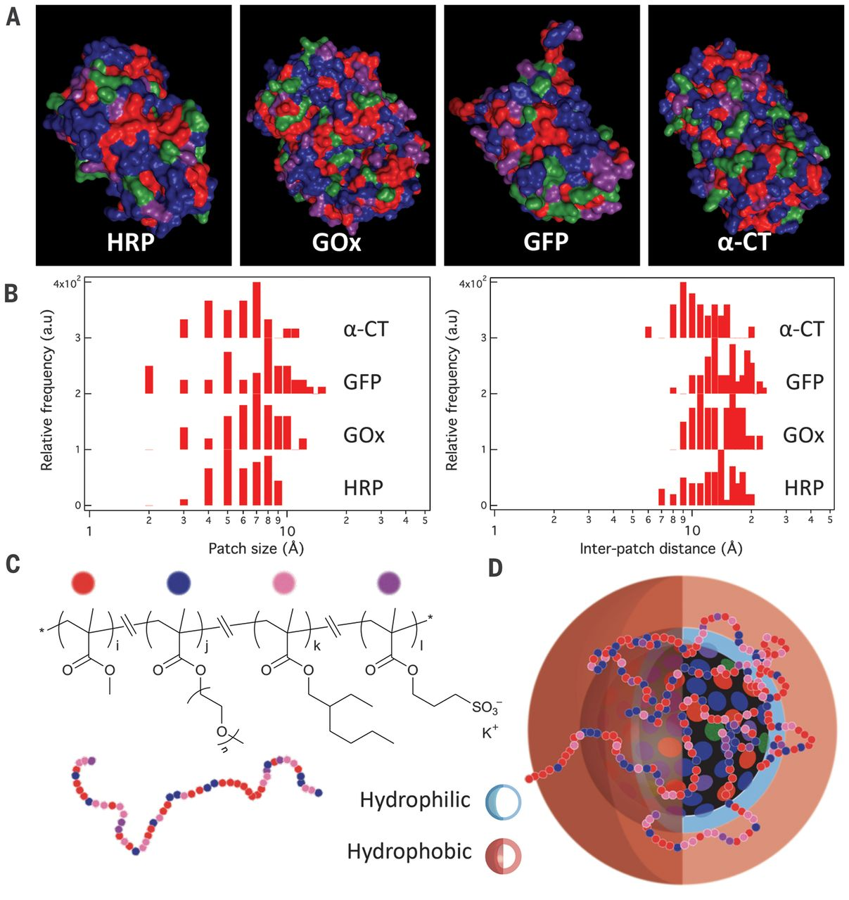

* The composition ratios that rank highest differ between Lip and GOx = enzyme specificity is evident.
  + Optimization must be performed for each enzyme.

Matthew J. Tamasi, Advanced Materials, 2022, 34, 30

1. **Bayesian optimization for GOx**

Bayesian optimization was performed for the thermostability of GOx.

* The objective value is the half-life (maximize the time until activity decays to 50%).
  + This can be switched to alternatives such as residual activity after 20 min of heating.
  + Because the experiments acquire time-resolved data at 5, 10, 15, 20, 40, and 60 min, we adopt the half-life as the target metric.

**グラフィカル ユーザー インターフェイス

AI 生成コンテンツは誤りを含む可能性があります。**

**Figure 15.** Bayesian surrogate and acquisition landscapes on the composition plane (Mean / Std / EI / UCB).

* Mean (μ):

The Gaussian Process (GP) surrogate’s predicted average of the objective (here, Predicted t50 (REA)). Think of it as the “performance map.”

* Std (σ):

The GP’s predictive standard deviation. This is uncertainty: small near data, large in unexplored areas or edges.

* EI (Expected Improvement):

Expected gain over the current best. It becomes large where μ is high *and* σ is non-negligible. Good for picking the “next best” experiments.

* UCB (Upper Confidence Bound):

μ + κσ (κ≈2.576 here). More exploratory: it rewards uncertain regions even if μ is modest.

Top-left: Mean

* Bright “islands” are compositions predicted to perform well.
* In your plots, a high-mean plateau sits around x ≈ 0.65–0.75, y ≈ 0.60–0.75 (roughly BMA 40–55%, MTAC 15–25%, MPC 20–35%).

Top-right: Std

* Dark near white circles (well-known), bright toward the corners/edges (poorly known).
* If you want to reduce model uncertainty itself, sample in bright-σ regions.

Bottom-left: EI

* Highlights where to try next. Peaks often hug the rim of a high-mean region where uncertainty still exists.
* In your figure, the EI hotspot tracks the edge of the high-mean plateau near x ~ 0.7, y ~ 0.7.

Bottom-right: UCB

* Lifts both high-μ and high-σ areas. Use when you prefer broader exploration.
* If an EI and UCB peak coincide, that point is a robust candidate.

グラフ

AI 生成コンテンツは誤りを含む可能性があります。

**Figure 16.** One-dimensional response profiles along composition axes (predictive mean with 95% CI).

* Gray band = 95% confidence interval (CI); a wider band indicates greater uncertainty.
* Black line = predictive mean; red circles = training data (experimental observations).
* The dashed line denotes the fixed value of the other coordinate (e.g., y=0.45).

→ Interpreted as a one-dimensional profile under fixed conditions. Inspect the peak location and the CI width to select several candidate coordinates for the next experiments.

グラフ, 散布図

AI 生成コンテンツは誤りを含む可能性があります。

**Figure 17.** Ternary map (left: MEAN, right: EI) of predicted performance across the MPC–MTAC–BMA space.

グラフ

AI 生成コンテンツは誤りを含む可能性があります。

**Figure 18.** right: Ternary map (Weighted MolLogP) of monomer-weighted hydrophobicity, left: Top 15 highlighted copolymer for GOx (weighted MolLogP) from Matthew J. Tamasi, Advanced Materials, 2022, 34, 30

I analyzed the top 15 polymers synthesized by Tamasi et al. Copolymer MolLogP was computed as a composition-weighted (mole-fraction-weighted) sum of the monomer MolLogP values. The majority of these top-15 polymers clustered around MolLogP ≈ 0.7–1.1. This coincides with the regions where my model reports high expected improvement (EI) (i.e., the bright areas in Figure 17). Whereas Tamasi et al. evaluated retained enzyme activity (REA) after heating at 65 °C for 30 min, our analysis targets the half-life (time to 50% activity), so a modest offset is expected. Even so, the proximity of the high-ranked regions across the two analyses supports the validity of our approach.

Next suggestion by Bayesian optimization.

グラフ, レーダー チャート

AI 生成コンテンツは誤りを含む可能性があります。

**Figure 19.** Mapping of candidates proposed by Bayesian optimization as having high EI

|  |  |  |  |  |  |
| --- | --- | --- | --- | --- | --- |
|  | $$x$$ | $$y$$ | **Feed Ratio (mol %)** | | |
|  | $$\frac{\left[BMA\right]}{\left[BMA\right]+ \left[MTAC\right]}$$ | $$\frac{\left[BMA\right]+ \left[MTAC\right]}{\left[MPC\right]+ \left[BMA\right]+ \left[MTAC\right]}$$ | **MPC** | **BMA** | **MTAC** |
| PMBTA-6 | 0.673 | 0.583 | 41.7 | 39.3 | 19.1 |
| PMBTA-7 | 0.629 | 0.749 | 25.1 | 47.2 | 27.8 |
| PMBTA-8 | 0.919 | 0.480 | 52.0 | 44.1 | 3.9 |

1. **Future Plan**

* Synthesize the newly proposed PMBTA-6, -7, and -8.
* Trial Bayesian optimization for Lip.
  + Decide whether to prioritize Lip or GOx when advancing subsequent optimization rounds.
* Discuss the objective value: half-life of activity vs REA after n minutes of heating.

1. **References**
2. Panganiban, B.; Qiao, B.; Jiang, T.; DelRe, C.; Obadia, M. M.; Nguyen, T. D.; Smith, A. A. A.; Hall, A.; Sit, I.; Crosby, M. G.; Dennis, P. B.; Drockenmuller, E.; Olvera de la Cruz, M.; Xu, T. Random Heteropolymers Preserve Protein Function in Foreign Environments. *Science* **2018**, 359, 1239–1243.
3. Tamasi, M. J.; Patel, R. A.; Borca, C. H.; Kosuri, S.; Mugnier, H.; Upadhya, R.; Murthy, N. S.; Webb, M. A.; Gormley, A. J. Machine Learning on a Robotic Platform for the Design of Polymer–Protein Hybrids. *Adv. Mater.* **2022**, 34, 2201809.
4. Nagao, M.; Nakahara, O.; Zhou, X.; Matsumoto, H.; Miura, Y. Bayesian Optimization of Glycopolymer Structures for the Interaction with Cholera Toxin B Subunit. *Nanoscale* **2024**, 12406-12410.